Microscopes Markscheme

- State the equation to calculate magnification using an image and its actual size.

Magnification = Size of Image
Size of Real Object

- Explain why electron microscopes are particularly useful.

They have a much higher magnification and resolution than light microscopes, meaning that even smaller objects can be looked at, furthering understanding of sub-cellular structures.

- Use the magnification equation to help you complete the missing values in the table. Show all working and units where necessary.

Size of Image | Size of Object | Magnification
10 mm | 0.001 mm | Magnification = image/object  10 mm/0.001 mm= 10000
20 mm | Object = Image/magnification  20 mm/5000 = 0.004 mm | 5000
Image = Object x magnification  0.005 mm x 10000 = 50 mm | 5 µm (= 0.005 mm) | 10000
15 mm | 0.03 mm | Magnification = image/object  15 mm/0.03 mm = 500
0.5 cm (= 5 mm) | Object = Image/magnification  5 mm/2500 = 0.002 mm | 2500
Image = Object x magnification  0.035 mm x 1000 = 35 mm | 0.035 mm | 1000
- The image below shows a chloroplast which has a length of 50 µm.
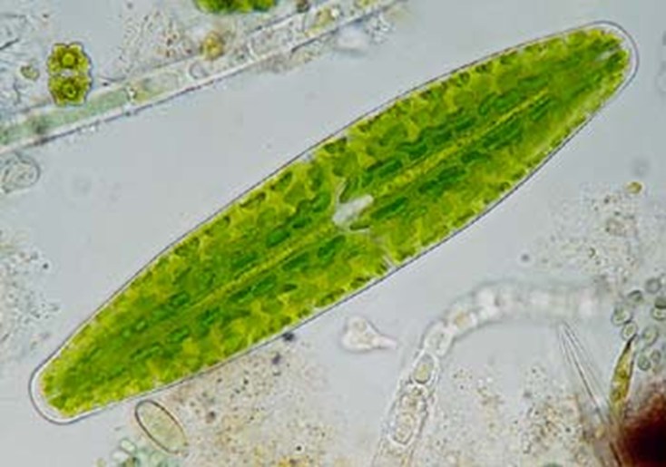

- Is 50 µm the image size or actual object size? Actual object size.

- Use a ruler to measure the length of the bar in the image. Depends on paper size for printing, measure with ruler (in mm)

- Use your measurement to calculate the magnification used to produce this image. Magnification = Value from measurement
0.05 mm
=________

- The image below shows a selection of red blood cells, with the diameter of one marked.
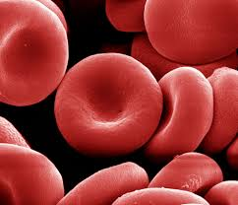

Measure the length of the diameter in the image. This image was obtained at a magnification of 5000.

Use this information to calculate the actual diameter of this red blood cell.

Magnification = Image size
Size of actual object

Size of actual object = Image size
Magnification
Object = Measured diameter (mm)
5000

= _______________ mm

- Ova have an approximate length of 0.1 mm. How big should an image of an ovum appear if it has been magnified 100 times?

Magnification = Image size
Size of actual object

Image size = Magnification x size of actual object

= 100 x 0.1

= 10 mm

